Activity Specification Document (Reviewed on JUL 09, 2026)
This chapter will present the specifications of the activity diagrams for the KriGo vehicle rental system. The activity diagrams are one of the behavioral diagrams that are part of the Unified Modeling Language (UML). They help in representing the workflow of the business processes and system operations. It represents the order of activities, control flows, decisions, parallel processes and interactions necessary for accomplishing the tasks within the system.
Whereas use case diagrams provide an identification of the functional requirements and sequence diagrams depict the interactions among the system objects through time, the activity diagrams represent the procedure of operations execution starting from their beginning till the completion of the process. Activity diagrams allow visualizing collaboration of users and system components when executing the business processes. Therefore, they are helpful in understanding the system behavior, verification of the business logic and identifying the alternative execution paths.
The activity diagrams presented in this chapter will cover the main workflow of the KriGo platform, including registration of customers, searching and selection of the vehicles, management of reservations, payment and review submissions, management of the fleet, management of branches and employees, verification of agencies, content moderation, dispute resolution, generation of AI recommendations, communication with the AI assistant, generation of analytics, and mobile application functionality, including quick booking and offline functionality. Moreover, an overview activity diagram will be presented illustrating the customer reservation process from the start till its completion with activity partitions (swimlanes) that involve various system participants.
The activity diagrams described the sequence of activities of a certain business process and highlight the decision points, alternative flows, validation techniques and synchronization points that determine the system behavior. When needed, the activity partitions will be used in order to separate the roles of various actors and system components involved in the process.
Activity diagrams serve as a crucial tool for the transition from the system requirements to the realization of the business processes. They help in visualization of operational workflows, verification of the business rules, process dependencies identification, and development, testing and maintenance of the KriGo system. With the help of activity diagrams, together with use case and sequence diagrams presented in previous chapters, we will build the full behavioral model of the system.

Contents
Customer Registration Process Activity 1
Vehicle Search & Selection Activity 4
Reservation Workflow Activity 6
Payment & Review Submission Activity 8
Fleet Management Workflow Activity 11
Branch & Employee Management Workflow Activity 13
Agency Verification Workflow Activity 15
Content Moderation Workflow Activity 17
Dispute Resolution Workflow Activity 19
Recommendation Workflow Activity 21
AI Assistant Workflow Activity 22
Analytics Generation Workflow Activity 23
Quick Booking Workflow Activity 24
Offline Access Workflow Activity 25
Location Services Workflow Activity 27
System Overview Activity Diagram (Customer Jurney) 28

Figures
Figure 1 - Customer Registration Process Activity Diagram 3
Figure 2 - Vehicle Search & Selection Activity Diagram 5
Figure 3 - Reservation Workflow Activity Diagram 7
Figure 4 - Payment & Review Submission Activity Diagram 10
Figure 5 - Fleet Management Workflow Activity Diagram 12
Figure 6 - Branch & Employee Management Workflow Activity Diagram 14
Figure 7 - Agency Verification Workflow Activity Diagram 16
Figure 8 - Content Moderation Workflow Activity Diagram 18
Figure 9 - Dispute Resolution Workflow Activity Diagram 20
Figure 10 - Recommendation Workflow Activity Diagram 21
Figure 11 - AI Assistant Workflow Activity Diagram 22
Figure 12 - AI Analytics Generation Workflow Activity Diagram 23
Figure 13 - Quick Booking Workflow Activity Diagram 24
Figure 14 - Offline Access Workflow Activity Diagram 26
Figure 15 - Location Services Workflow Activity Diagram 27
Figure 16 - System Overview Activity Diagram 28

Customer Registration Process Activity
The diagram of the Customer Registration Process shows the process of forming the new customer account in the KriGo platform. This activity diagram shows the order of actions that are taken by the customer and the system in the process of customer registration. The emphasis is put on the flow of control, decisions made, and validations required to make sure that only valid customer data is provided.

Workflow Description
Registration starts after the user visits the registration page on the KriGo website. After filling out personal information such as name, contact number, and address, as well as login details like the email address and password, the registration process proceeds.
When the registration form is filled in, it is then submitted to the system. The system will validate the information provided by checking if all mandatory data fields are correctly filled in and the provided information adheres to the platform's validation criteria.
In case of validation failure, the system will show validation errors alongside returning the user back to the registration form. Invalidation of the data implies that the provided data must be corrected before submitting.
If the data is validated, the system will check if the email provided belongs to an existing user. If the email address already exists in the system, the user will be notified about it and asked to use another email address.
If the email is new, the system will create a customer account, save the information to the database, send an email verification message, and notify the user that he has registered successfully.
Main Activities
The Customer Registration Process Activity Diagram consists of the following primary activities:
- Open the registration page.
- Enter personal information.
- Enter account credentials.
- Submit the registration form.
- Validate the submitted information.
- Verify the uniqueness of the email address.
- Create the customer account.
- Save customer information.
- Send a verification email.
- Display the registration confirmation.

Decision Points
The activity diagram contains two main decision nodes:
- Information Valid?
  - If yes, the registration process proceeds to email verification.
  - If no, validation errors are displayed and the customer returns to the registration form.
- Email Already Exists?
  - If yes, the system informs the customer that the email is already registered and returns to the registration form.
  - If no, the customer account is created successfully.
These decision points ensure that only complete, accurate, and unique customer information is accepted by the platform.
Alternative Flows
The Customer Registration Process Activity Diagram includes the following alternative scenarios:
- Submission of incomplete or invalid registration information.
- Attempt to register using an email address that already exists.
- Successful customer registration after all validation checks have been satisfied.
These alternative paths improve the reliability and integrity of the registration process while providing clear feedback to the customer whenever corrective action is required.

Conclusion
The Customer Registration Process Activity Diagram is a very detailed depiction of the process flow involved in registering an account for customers through the KriGo application. The diagram depicts the process flow of all the actions involved in order to be able to register an account successfully. The activity diagram acts as a significant behavioral model of the operation involved in one of the critical functions of the application.
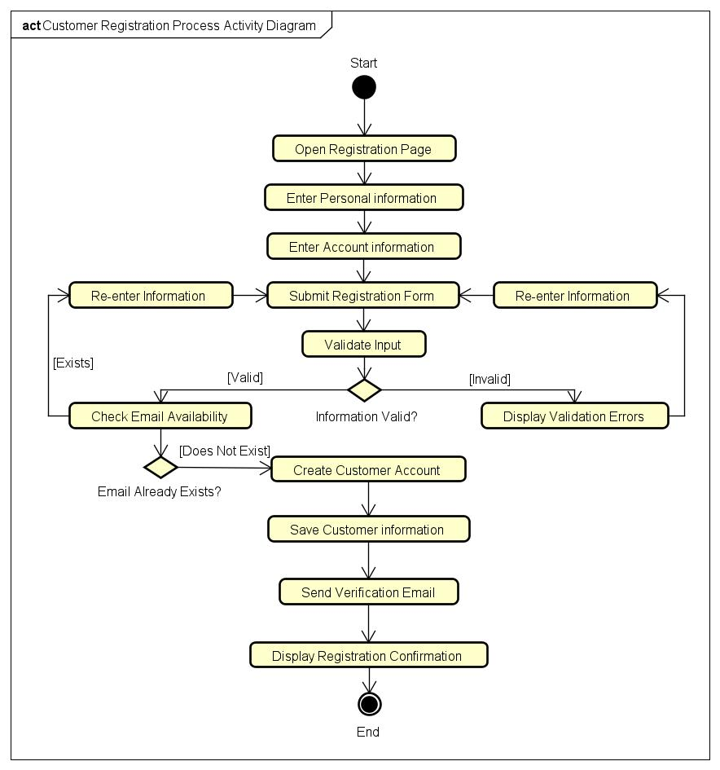
Figure 1 - Customer Registration Process Activity Diagram

Vehicle Search & Selection Activity
Purpose
The Vehicle Search & Selection Activity Diagram represents the process by which clients search for available vehicles and choose a fitting vehicle to make a reservation in the KriGo system. The diagram presents the activities, decisions, and alternatives related to finding vehicles that meet client requirements.
Workflow Description
The process starts with the client accessing the vehicle search screen. The client sets the search criteria, such as pick-up point, rental period, car type, price range, and other filters. Then, all vehicles that fit the set criteria and are available for the required period of time will be retrieved.
In case there are no vehicles that meet the set criteria, the customer will be notified about the result and allowed to change the criteria and perform the search again.
If there are some vehicles that meet the set criteria, the client examines the list of search results and chooses a particular vehicle that he/she wants to examine further and see all the details about the chosen one.
Then, the client makes the decision regarding the suitability of the chosen vehicle for renting and proceeds either to making the reservation or continues to search for other fitting vehicles.
Main Activities
The Vehicle Search & Selection Activity Diagram includes the following primary activities:
- Open the vehicle search interface.
- Enter search criteria.
- Submit the search request.
- Retrieve matching available vehicles.
- Display search results.
- Browse available vehicles.
- Select a vehicle.
- View vehicle details.
- Proceed to the reservation process.
Decision Points
The activity diagram contains two primary decision nodes:
- Vehicles Found?
  - If yes, the customer browses the available vehicles.
  - If no, the system displays a message indicating that no vehicles match the search criteria, allowing the customer to modify the search.
- Vehicle Meets Requirements?
  - If yes, the customer proceeds with the reservation process.
  - If no, the customer returns to the search results to evaluate other vehicles.
These decision points ensure that customers can efficiently identify vehicles that best satisfy their rental preferences while handling situations where no suitable vehicles are immediately available.
Alternative Flows
The Vehicle Search & Selection Activity Diagram incorporates several alternative scenarios:
- No vehicles match the specified search criteria.
- The selected vehicle does not satisfy the customer's preferences.
- Successful vehicle selection leading to the reservation process.
These alternative paths provide flexibility during the vehicle selection and enhance overall UX.
Conclusion
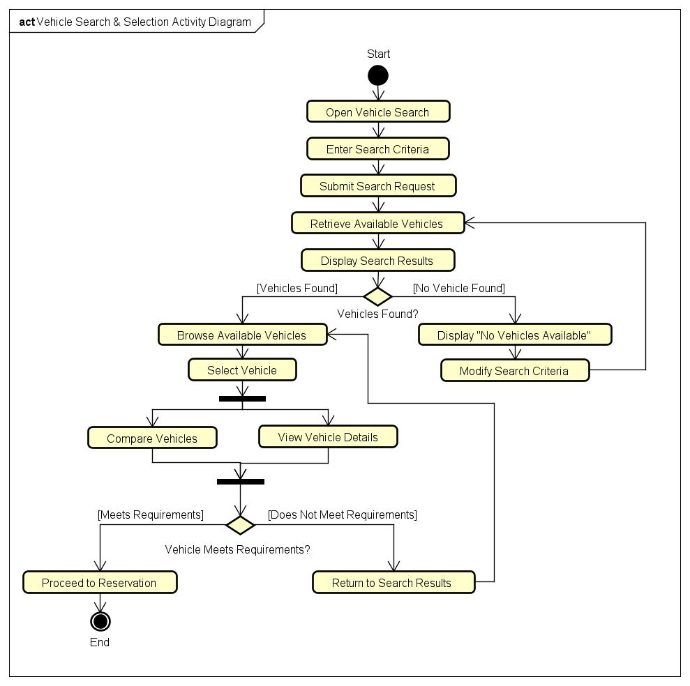
The Vehicle Search and Selection Activity Diagram give a detailed view of all the processes included in the process of finding and selecting rental cars within the KriGo application. The diagram shows how these processes are structured logically, starting with the entry of search parameters and ending with the selection of a suitable vehicle.
Figure 2 - Vehicle Search & Selection Activity Diagram

Reservation Workflow Activity
Purpose
Activity Diagram of Reservation Process Workflow is a diagram that shows all activities performed when making a car reservation in the KriGo system. The activity diagram demonstrates the entire reservation process from choosing a car and inserting reservation details to checking its availability, calculating the price of the car, confirming the reservation and saving the reservation information.
Workflow Description
The process of making reservations involves the choice by the customer of a car among the available search results. The next step is providing the required information on the rental: location of picking up, dates of pick up and return, and making a reservation.
When the system gets the request, it checks the availability of the chosen car within the requested period of time. If the vehicle is not available, the customer gets informed about this fact and is redirected to the vehicle search page.
If the chosen vehicle is available, the system calculates the price of the rental based on the rental period and rules.
After reviewing the reservation details, the customer makes a decision on reserving the car. In case of making the reservation, the system saves the reservation information and sends the confirmation message to the customer. If the client does not want to reserve the car anymore, the reservation process is cancelled.
Main Activities
The Reservation Workflow Activity Diagram includes the following primary activities:
- Select a vehicle.
- Enter reservation details.
- Submit the reservation request.
- Check vehicle availability.
- Calculate the rental cost.
- Display the reservation summary.
- Confirm the reservation.
- Create and save the reservation.
- Display the reservation confirmation.
Decision Points
The activity diagram contains two main decision nodes:
- Vehicle Available?
  - If Yes, the reservation process continues with rental cost calculation and reservation review.
  - If No, the customer is informed that the vehicle is unavailable and returns to the vehicle search process.
- Confirm Reservation?
  - If Yes, the reservation is created and stored successfully.
  - If No, the reservation process is canceled without saving any data.
These decision points ensure that reservations are created only for available vehicles and only after explicit customer confirmation.
Alternative Flows
The Reservation Workflow Activity Diagram incorporates several alternative scenarios:
- The selected vehicle is unavailable for the requested rental period.
- The customer cancels the reservation before confirmation.
- Successful reservation creation and confirmation.
These alternative paths improve system reliability by preventing duplicate bookings and allowing customers to review their reservation details before finalizing the transaction.
Conclusion
Reservation Workflow Activity Diagram acts as the most detailed description of the whole process of reserving a car through the KriGo system. It describes the entire logical sequence of actions, validations, and decisions needed to reserve the car. This activity diagram is a vital part of behavioral modeling of the reservation subsystem.
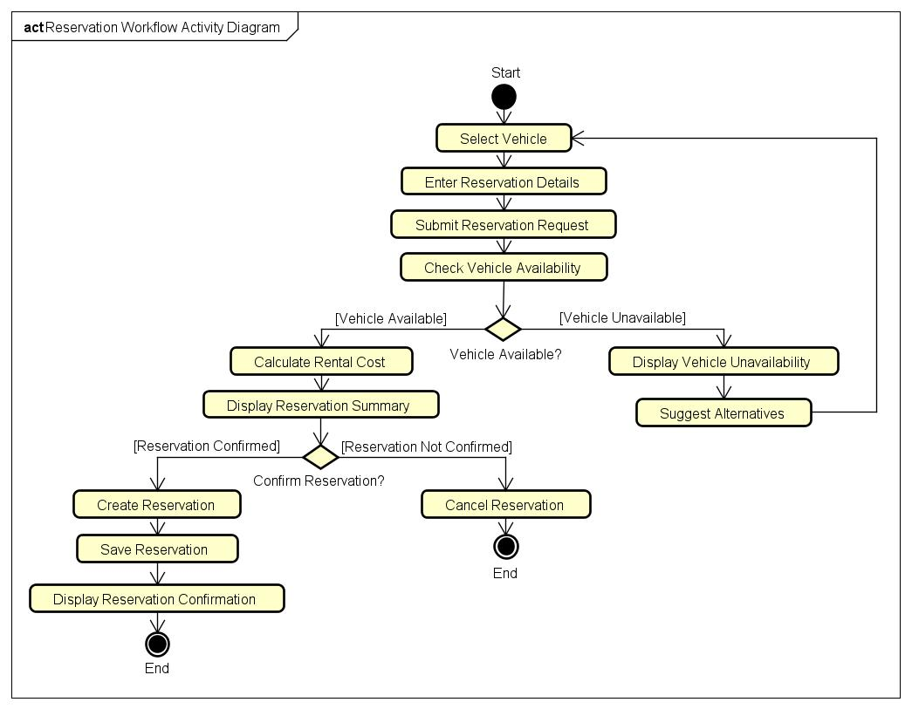
Figure 3 - Reservation Workflow Activity Diagram

Payment & Review Submission Activity
Purpose
Activity Diagram for Payment & Review Submission presents the process involved in making the payment for the car reservation and subsequently providing the client review after the successful completion of the rental services provided in the KriGo website. The activity diagram shows the series of activities in the payment process using Edahabia payment system and reservation status update process.
Workflow Description
This is done by displaying a summary of the reservation made by the customer including the selected vehicle, period of time, and the total payment. The customer selects Edahabia as the means of payment and fills in the necessary payment details.
These details are validated by the system and the payment request is forwarded to the online payment system for validation. In case the payment fails, the customer is notified of the failure of the transaction and he can either try again to make the payment or cancel the reservation.
Upon successful payment, the status of the reservation changes and a message confirming the payment is displayed to the customer.
At the end of the renting, the customer is given the opportunity to give feedback about his renting experience. This is done by filling in the rating and comments on the renting experience. The feedback is then validated and stored in the database.
Main Activities
The Payment & Review Submission Activity Diagram includes the following primary activities:
- Display the reservation summary.
- Select the Edahabia payment method.
- Enter payment information.
- Validate payment details.
- Process the online payment.
- Update the reservation status.
- Display payment confirmation.
- Complete the rental.
- Enter a rating and written review.
- Validate and save the review.
- Display the review submission confirmation.

Decision Points
The activity diagram contains three primary decision nodes:
- Payment Successful?
  - If Yes, the reservation status is updated and the payment is confirmed.
  - If No, the customer may retry the payment or cancel the transaction.
- Retry Payment?
  - If Yes, the customer re-enters the payment information.
  - If No, the payment process is canceled.
- Submit Review?
  - If Yes, the customer submits a rating and written review.
  - If No, the workflow ends after the payment process.
These decision points ensure secure payment processing while allowing customers to provide valuable feedback after completing their rental experience.
Alternative Flows
The Payment & Review Submission Activity Diagram incorporates several alternative scenarios:
- Payment authorization fails and the customer retries the payment.
- Payment is canceled before successful completion.
- Customer completes the payment but chooses not to submit a review.
- Successful payment followed by successful review submission.
These alternative paths improve the flexibility and reliability of the payment and feedback processes while ensuring that reservation records and customer reviews are accurately maintained.
Conclusion
The activity diagram called Payment & Review Submission is a detailed visual presentation of the activities that are to be performed in order to make the reservation payment and to receive the customer’s feedback using the KriGo system. The diagram shows the logical sequence of actions starting from the payment authorization to the option of leaving the feedback.

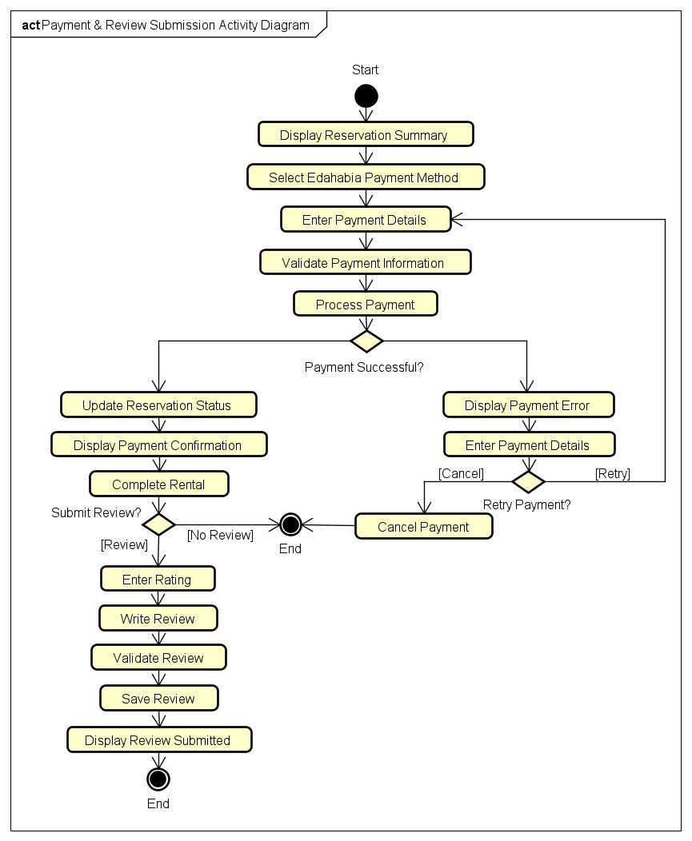
Figure 4 - Payment & Review Submission Activity Diagram

Fleet Management Workflow Activity
Purpose
The Fleet Management Workflow Activity Diagram is the diagram that shows the order of activities in the process of vehicle fleet management in the KriGo application. The diagram represents the process that the rental agency or the administrator uses while performing fleet management tasks, such as adding new cars, editing data about the car, maintaining it, and deleting cars from the list. The diagram demonstrates the control flow and validation steps used to keep data correct and up to date.
Workflow Description
The process starts by either logging into the fleet management module by the agency/ administration or the system administrator. The user chooses the appropriate operation that could include adding a new vehicle, changing information about vehicles already added, scheduling the maintenance activities for the vehicle or deactivating a vehicle.
Based on the chosen operation, the information about the vehicle or the maintenance activity is inputted or updated. Prior to saving any data, the system will validate the information provided to make sure that all necessary information is there and follows the rules of the business.
In case of failure to pass the validation process, the system will provide the validation errors and give the chance to fix the issue and repeat the process again. Once the validation passed successfully, the information will be saved.
Main Activities
The Fleet Management Workflow Activity Diagram includes the following primary activities:
- Access the Fleet Management module.
- Select a fleet management operation.
- Add a new vehicle.
- Update vehicle information.
- Schedule vehicle maintenance.
- Remove a vehicle from the fleet.
- Validate submitted information.
- Update fleet records.
- Save changes.
- Display a confirmation message.
Decision Points
The activity diagram contains two primary decision nodes:
- Operation Type?
- Add Vehicle.
- Update Vehicle Information.
- Schedule Maintenance.
- Remove Vehicle.
- Information Valid?
  - If Yes, the system updates the fleet records and saves the changes.
  - If No, validation errors are displayed and the user returns to correct the submitted information.
These decision points ensure that only valid fleet information is stored while supporting multiple fleet management operations through a unified workflow.
Alternative Flows
The Fleet Management Workflow Activity Diagram incorporates several alternative scenarios:
- Adding a new vehicle to the fleet.
- Updating existing vehicle information.
- Scheduling maintenance for a vehicle.
- Removing a vehicle from the fleet.
- Submission of invalid or incomplete information requiring correction before processing.
These alternative paths ensure that the fleet management subsystem remains flexible while preserving the integrity and consistency of vehicle records.
Conclusion
The Fleet Management Workflow Activity Diagram is the most comprehensive diagram that depicts the process of managing the vehicle fleet in the KriGo platform. The activity diagram describes the logical process of fleet management, validation steps, and decisions that should be made in order to keep the records about the vehicles up to date. The activity diagram can be considered one of the behavioral models of the fleet management system.
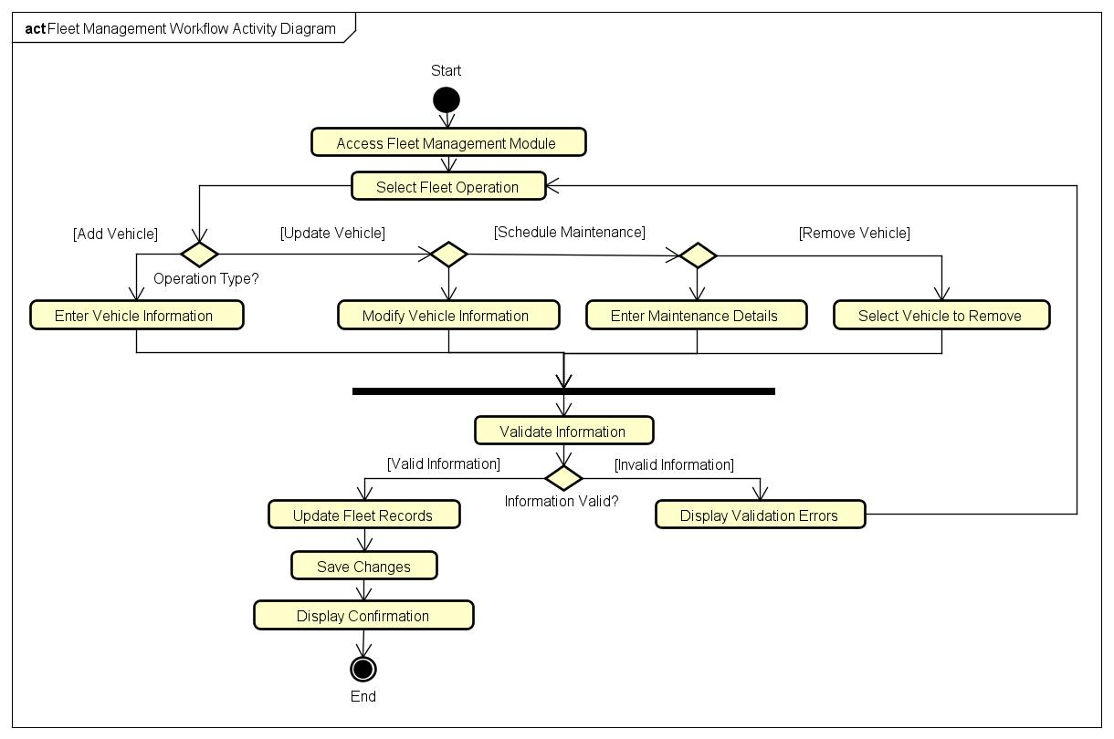
Figure 5 - Fleet Management Workflow Activity Diagram

Branch & Employee Management Workflow Activity
Purpose
Activity Diagram of Workflow in Branches and Employee Management Workflow Activity Diagram provides a graphical depiction of the workflow related to management of branch offices and employee records in the KriGo framework. This activity diagram describes the activities carried out in the process of creation, modification, assignment, and removal of branches and employees by the system administrator or agency manager.
Workflow Description
This process starts by the system administrator or agency manager logging into the Branch & Employee Management module. The user will select the relevant management action to be performed, such as creation of a new branch, modification of existing branch information, creation of new employee, modification of existing employee information, assignment of employee to a branch or removal of existing branches and employees.
Depending on the selected action, the system will prompt the user for the relevant information to be updated. The system will then validate the entered information to ensure that the mandatory fields have been entered and the entered information conforms to the business rules of the system.
In case validation fails, the system will display validation errors and allow the user to modify the entered information. In case validation passes, the system will save the entered information and return a confirmation message stating the success of the action.
Main Activities
The Branch & Employee Management Workflow Activity Diagram includes the following primary activities:
- Access the Branch & Employee Management module.
- Select a management operation.
- Add, Update, Remove a branch.
- Add, Update, Remove an employee.
- Assign an employee to a branch.
- Validate submitted information.
- Save changes.
- Update the database.
- Display a confirmation message.
Decision Points
The activity diagram contains two primary decision nodes:
- Operation Type?
  - Add, Update, Remove Branch.
  - Add, Update, Remove Employee.
  - Assign Employee to Branch.
- Information Valid?
  - If yes, the system saves the changes and updates the database.
  - If no, validation errors are displayed and the user returns to the selected operation to correct the information.
These decision points ensure that organizational records are updated accurately while supporting multiple branch and employee management operations through a unified workflow.
Alternative Flows
The Branch & Employee Management Workflow Activity Diagram incorporates several alternative scenarios:
- Creating, Updating, Removing a new branch.
- Registering, Updating, Removing branch employee.
- Assigning an employee to a specific branch.
- Submission of invalid or incomplete information requiring correction before processing.
These alternative paths provide flexibility for administrative tasks while preserving the integrity and consistency of branch and employee records.
Conclusion
Branch and Employee Management Workflow Activity Diagram present a full overview of the administrative activities related to managing branches and employees in the KriGo system. It shows the sequence of the activities, validations, and decisions that need to be performed to ensure accuracy of the organizational data. Activity diagram is a very important behavioral model used to describe the administration subsystem.

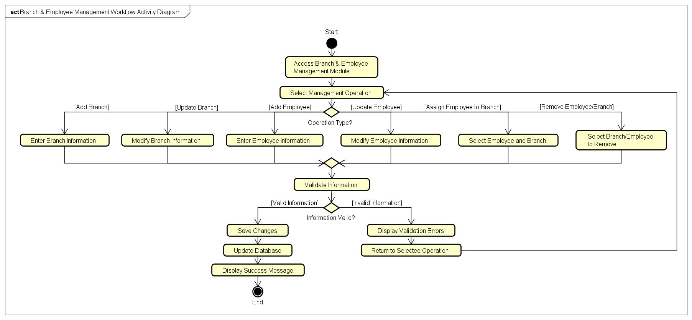
Figure 6 - Branch & Employee Management Workflow Activity Diagram

Agency Verification Workflow Activity
Purpose
This diagram shows the workflow that helps to verify the rental agency prior to its authorization to use the KriGo service. This procedure guarantees the legitimacy and proper documentation of the agencies and thus makes the platform reliable, credible, and secure.
Workflow Description
At first, the agency fills out its registration form and uploads all necessary verification documents, such as business licenses, registration certificates, and additional documents. The agency then submits the verification request for review.
The system administrator reviews the submitted application and checks the correctness of the documents attached to it. In case there are some lacking or incorrect documents in the application, the application will be denied and the agency will be informed about it.
If the documents are correct, the administrator will start to check the information provided by the agency. Then, based on the verification results, the administrator will either approve or deny the application. The approved agency will be able to use the platform as its account will be active, while the denied agency will be notified about this.
Main Activities
The Agency Verification Workflow Activity Diagram includes the following primary activities:
- Submit agency registration.
- Upload required verification documents.
- Submit the verification request.
- Review the application.
- Validate submitted documents.
- Verify agency information.
- Activate the agency account.
- Notify the agency of the verification result.
Decision Points
The activity diagram contains two primary decision nodes:
- Documents Valid?
  - If yes, the administrator proceeds with agency verification.
  - If no, the application is rejected and the agency is notified of missing or invalid documents.
- Verification Approved?
  - If yes, the agency account is activated and an approval notification is sent.
  - If no, the application is rejected and the agency receives a rejection notification.
These decision points ensure that only agencies meeting the platform's verification requirements are authorized to provide vehicle rental services.

Alternative Flows
The Agency Verification Workflow Activity Diagram incorporates several alternative scenarios:
- Submission of incomplete or invalid verification documents.
- Rejection of the agency application following administrative review.
- Successful verification and activation of the agency account.
These alternative paths provide a controlled verification process while maintaining the integrity and trustworthiness of the KriGo platform.
Conclusion
Agency Verification Workflow Activity Diagram provides an extensive graphical description of the process of agency verification on KriGo platform. This diagram includes the steps that are taken in order to verify whether the agency can be approved or rejected from using KriGo services. Such activity diagram is used as an important behavior model to guarantee that only verified agencies will work on the platform.
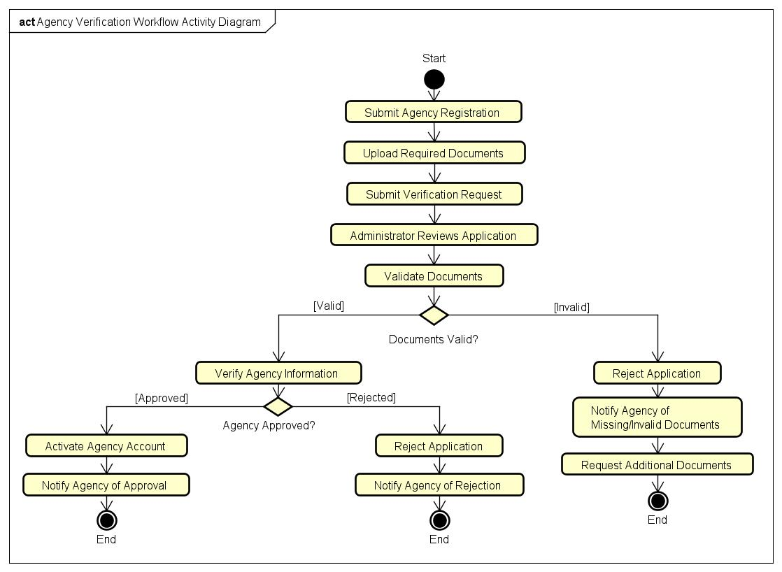
Figure 7 - Agency Verification Workflow Activity Diagram

Content Moderation Workflow Activity
Purpose
The Content Moderation Workflow Activity Diagram provides an illustration of the procedure that the KriGo platform goes through to ensure that any user-generated content that gets published either before or after is moderated properly. The moderation process involves ensuring that all the reviews, comments, and other contributions adhere to the community guidelines of the platform.
Workflow Description
The process begins with the customers uploading their content through the KriGo system. The system will begin with validating the uploaded information to ensure all information needed is available and the information is in the correct format. After validation, there will be the moderation process where the system will screen the uploaded content for any language and content policies.

If no violation of the policies is detected, then the content is automatically published and a message to this effect is communicated to the customer. However, if the content violates the system’s policy on moderation, then the content will be flagged for further review by the system administrator. The administrator reviews the flagged content to determine if it complies with the moderation policy of the platform. If approved by the administrator, then the content will be published and a message will be sent to the customer indicating successful publication.
Main Activities
The Content Moderation Workflow Activity Diagram includes the following primary activities:
- Submit user-generated content.
- Validate the submission.
- Perform automatic content screening.
- Detect potential policy violations.
- Flag content for administrator review.
- Review flagged content.
- Publish approved content.
- Reject non-compliant content.
- Notify the customer of the moderation outcome.
Decision Points
The activity diagram contains two primary decision nodes:
- Policy Violation Detected?
  - If yes, the content is flagged for manual review.
  - If no, the content is published immediately.
- Approve Content?
  - If yes, the content is published.
  - If no, the content is rejected and remains unpublished.
These decision points ensure that inappropriate or non-compliant content is prevented from appearing on the platform while allowing legitimate contributions to be published efficiently.
Alternative Flows
The Content Moderation Workflow Activity Diagram incorporates several alternative scenarios:
- Automatic approval and publication of compliant content.
- Automatic detection of suspected policy violations.
- Manual approval of flagged content after administrator review.
- Rejection of content that violates platform policies.
These alternative paths provide a balanced moderation process that combines automation for efficiency with human oversight for accurate decision-making.
Conclusion
The Activity Diagram on Content Moderation Workflow provides a detailed representation of the entire moderation process that is inherent to the KriGo system. This diagram describes the steps of actions, automatic validation checks, review by the administrators, and decision-making required for ensuring a safe and trusted space for the user-generated content.
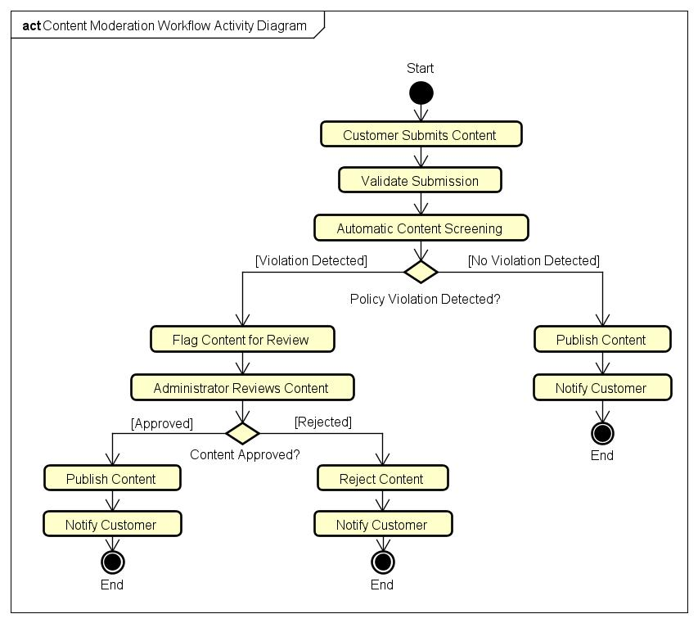
Figure 8 - Content Moderation Workflow Activity Diagram

Dispute Resolution Workflow Activity
Purpose
The Dispute Resolution Workflow Activity Diagram presents the process followed by the KriGo platform in resolving disputes sent by customers or rental agencies. The main objective of this process is to provide for an unbiased analysis of the reported dispute, investigation of the reported case based on existing evidence, and making a resolution of the reported case.
Workflow Description
Disputes are received by the KriGo platform whenever there is a problem with a reservation, payment, condition of the rented vehicle, or any other issues related to rentals. As a part of the dispute reporting process, the submitter provides supporting evidence such as photos or payment receipts.
Information that has been submitted is validated in order to verify if all required information is submitted. In case of the lack of required information, the submitter is asked to provide it as a part of the dispute review process.
After all information has been submitted successfully, the dispute is assigned to a system administrator who will review the case and analyze the available evidence. In case of the lack of evidence, the system administrator asks for additional evidence.
When all necessary work has been completed, the administrator makes the decision regarding the solution of the problem. The decision could be either approval of the refund or denial of the claim.
Main Activities
The Dispute Resolution Workflow Activity Diagram includes the following primary activities:
- Submit a dispute.
- Upload supporting evidence.
- Validate dispute information.
- Assign the dispute to an administrator.
- Review the dispute.
- Investigate the submitted evidence.
- Determine the appropriate resolution.
- Update the dispute status.
- Notify the customer and rental agency.
Decision Points
The activity diagram contains two primary decision nodes:
- Information Complete?
  - If yes, the dispute proceeds to administrator review.
  - If no, the system requests additional information before processing continues.
- Resolution Reached?
  - If yes, the administrator finalizes the dispute, updates its status, and notifies the involved parties.
  - If no, additional supporting evidence is requested to continue the investigation.
These decision points ensure that disputes are resolved only after sufficient information has been collected and carefully evaluated.
Alternative Flows
The Dispute Resolution Workflow Activity Diagram incorporates several alternative scenarios:
- Submission of incomplete dispute information requiring additional details.
- Investigation requiring further supporting evidence before a decision can be made.
- Successful dispute resolution after administrative review.
- Notification of the final decision to both the customer and the rental agency.
These alternative paths help ensure fairness, consistency, and transparency throughout the dispute resolution process.
Conclusion
Dispute Resolution Workflow Activity Diagram gives a complete illustration of how disputes are handled in the KriGo platform. The diagram clearly illustrates the sequence of actions, validation process, investigation steps, and decisions needed to resolve any disputes effectively between customers and agencies. The activity diagram plays a crucial role in behavioral modeling in order to maintain quality services and ensure that all stakeholders' interests are protected.

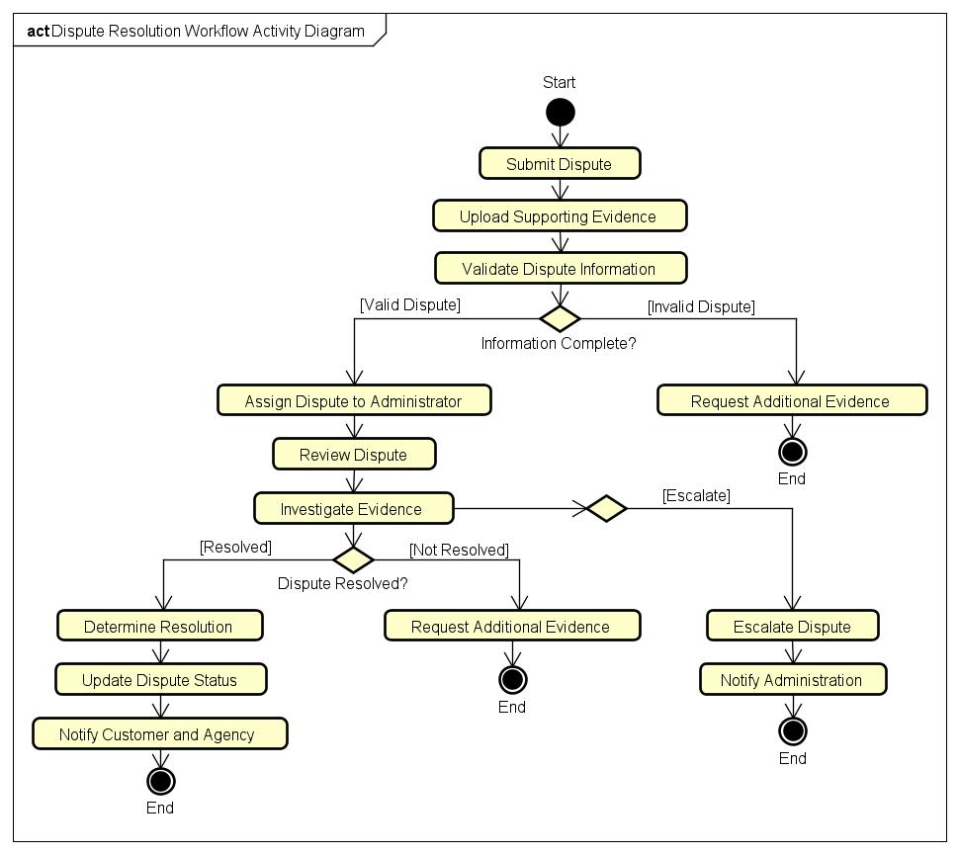
Figure 9 - Dispute Resolution Workflow Activity Diagram

Recommendation Workflow Activity
Purpose
Recommendation Workflow Activity Diagram illustrates the order in which the KriGo platform develops customized vehicle recommendations for customers. Analyzing customer preferences, reservation history, and the availability of the vehicle helps the recommendation engine find the best suitable vehicles for customers.
Workflow Description
This workflow starts when the customer asks for personalized recommendations. It uses customer information, including the customer’s profile and the customer’s previous reservation history, and acquires information about currently available vehicles. By processing this input, the recommendation engine evaluates customer preferences and comes up with the list of appropriate vehicles.
If there are personalized recommendations, they are displayed to the customer. If there are no personalized recommendations, the system shows a list of top-rated or popular vehicles to make sure that some useful recommendations are shown.
Main Activities
- Request recommendations.
- Retrieve customer profile, available vehicles.
- Analyze customer preferences and reservation history.
- Generate recommendations.
- Display personalized or popular vehicle suggestions.
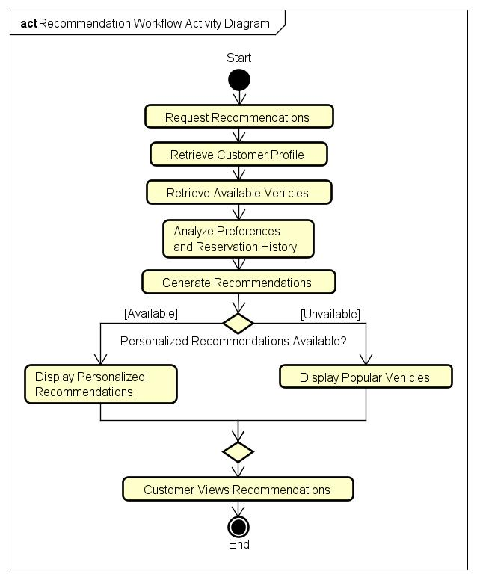
- View recommendations.
Figure 10 - Recommendation Workflow Activity Diagram
Decision Point
Recommendations Available?
- Yes: Display personalized recommendations.
- No: Display popular vehicles.

Conclusion
The Recommendation Workflow Activity Diagram demonstrates how the AI recommendation engine transforms customer data and vehicle availability into personalized suggestions, improving the overall booking experience and helping customers discover suitable rental vehicles efficiently.

AI Assistant Workflow Activity
Purpose
AI Assistant Workflow Activity Diagram shows the process through which users will interact with the AI assistant that forms part of the KriGo system. This workflow explains how users' requests will be processed, relevant information will be extracted, and intelligent responses will be formulated to assist in reservations, questions about vehicles, payment transactions, and any other questions related to the platform.
Workflow Description
The workflow begins with the user asking the AI assistant a question or making a request. The system will analyze the user's input and identify the nature of the request. Relevant information will then be extracted and used to generate a natural language response to the request. If there is no suitable response, the system will advise the user to contact customer support.
Main Activities
- Open the AI assistant.
- Enter a question.
- Process the user request.
- Determine the request type.
- Retrieve relevant information.
- Generate an AI response.
- Display the response or recommend customer support.
Decision Point
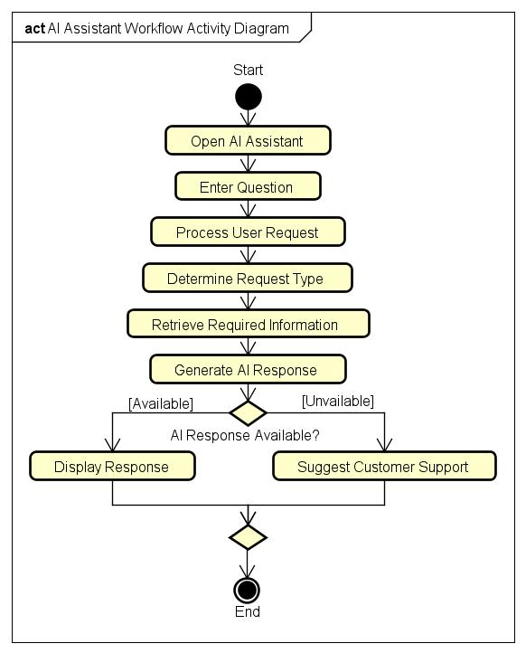
Response Available?
Figure 11 - AI Assistant Workflow Activity Diagram
- Yes: Display the generated response.
- No: Suggest contacting customer support.

Conclusion
Workflow diagram for Activity of AI Assistant shows how Conversational AI helps in customer support through intelligent real time support, while any un-resolved queries are routed to the customer support team.

Analytics Generation Workflow Activity
Purpose
Analytics Generation Workflow Activity Diagram shows the way in which the KriGo platform collects operational data, performs analysis and derives business insights for the administration. This workflow assists in making data-driven decisions through conversion of reservation, payment and fleet data into meaningful reports and dashboards.
Workflow Description
This workflow starts when the system administrator makes a request for an analytics report. The system accesses reservation data, payment transactions, and fleet management data stored in the database. Datasets are processed in the analytics engine for calculation of KPIs and trends to make visual reports.
Depending on whether the data is sufficient, either dashboards and analytics reports will be generated for presentation to the administrator or the system will notify the administrator that analytics reports cannot be created because of insufficient data for the selected criteria.
Main Activities
- Request analytics report.
- Retrieve data of reservation, payment, fleet.
- Aggregate operational data.
- Generate analytics.
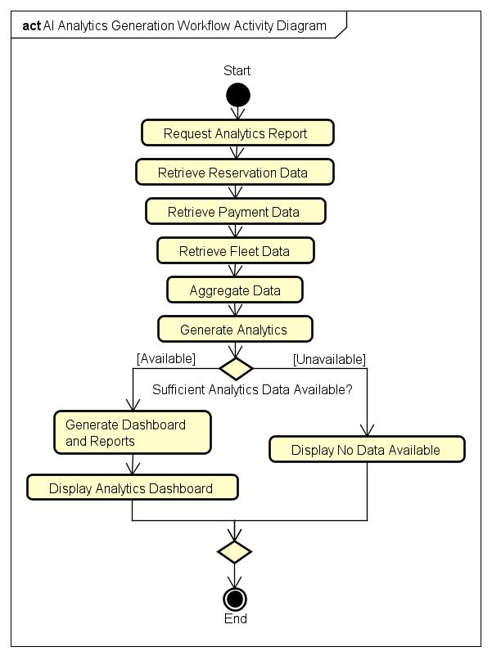
- Produce dashboards and reports.
Figure 12 - AI Analytics Generation Workflow Activity Diagram
- Display analytics results.
Decision Point
Data Available?
- Yes: Generate and display dashboards and reports.
- No: Display a message indicating that no data is available.
Conclusion
Analytics Generation Workflow Activity Diagram depicts how the operational data collected from various modules is turned into useful business intelligence. Through creation of dashboards, performance indicators, and analytics reports, the workflow helps in efficient monitoring and decision-making.

Quick Booking Workflow Activity
Purpose
Quick Booking Workflow Activity Diagram illustrates the process of fast vehicle reservation possible through KriGo mobile application. The process allows customers to book an available vehicle using few interactions, thus providing a fast and convenient booking procedure along with checking the availability of the vehicle before making the reservation.
Workflow Description
The process starts with the customer opening the application and looking at the list of available vehicles. After choosing a vehicle, the system checks the availability of the chosen vehicle during the rental period. In case of vehicle being available, the user confirms the booking process, and the system makes the reservation, saves the booking information, and gives the confirmation of the booking. In case if the chosen vehicle is not available, the system alerts the user about it.
Main Activities
- Open the mobile application.
- Browse available vehicles.
- Select a vehicle.
- Check vehicle availability.
- Confirm quick booking.
- Create the reservation.
- Display the booking confirmation.
Decision Point
Vehicle Available?
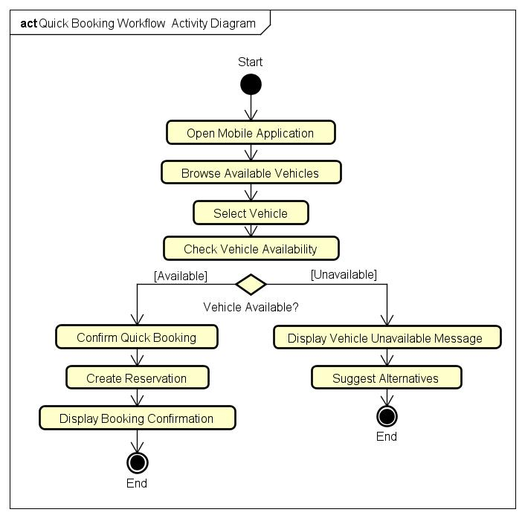
- Yes: Create the reservation and display confirmation.
Figure 13 - Quick Booking Workflow Activity Diagram
- No: Inform the customer that the vehicle is unavailable.
Conclusion
Activity diagram for Quick Booking Workflow depicts how the reservation process is simplified by using the KriGo application without compromising the accuracy of the reservations through availability check.

Offline Access Workflow Activity
Purpose
Offline Access Workflow Activity Diagram presents the way the KriGo mobile application operates in case of absence of internet connection. In this way, customers will be able to access cached data and perform supported actions offline with further synchronization of local data with the central system when the internet connection is restored.
Workflow Description
Offline Access Workflow starts when the customer launches the mobile application. The application detects whether the internet connection is available.
In case the device has an internet connection, the customer can work with the platform in the usual way. In case there is no internet connection, the application opens the data that have been cached earlier, making it possible for the customer to use offline supported functionality.
All actions made in offline mode are cached locally in the mobile device. The application continuously detects whether there is internet connection. All changes made in offline mode will be synchronized with the central database after the internet connection is restored.
Main Activities
- Open the mobile application.
- Check internet connectivity.
- Load cached data.
- Perform offline operations.
- Store changes locally.
- Synchronize local data.
- Update synchronization status.
Decision Points
Internet Connection Available?
- Yes: Access online platform features.
- No: Load cached information and continue offline.
Connection Restored?
- Yes: Synchronize locally stored changes.
- No: Continue operating in offline mode.

Conclusion
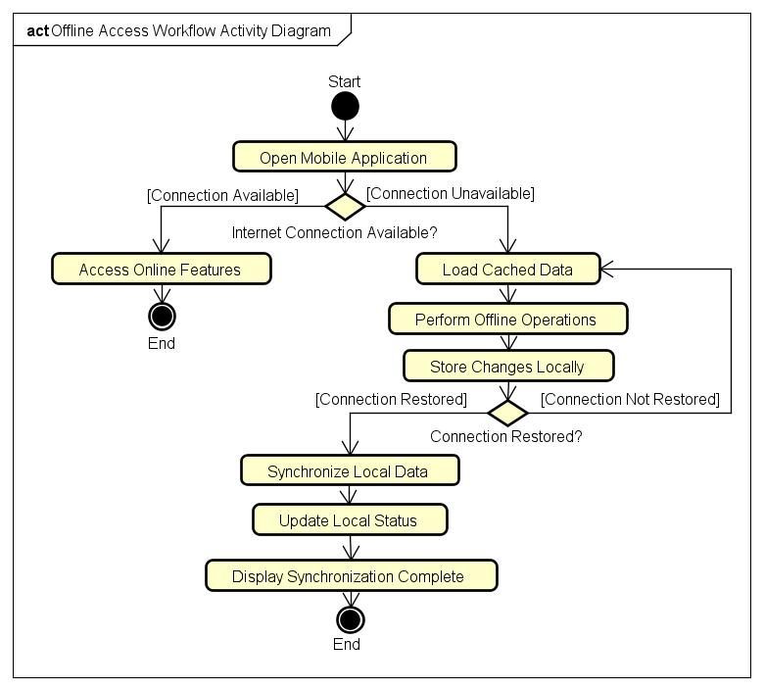
Offline Access Workflow Activity Diagram shows how the KriGo mobile application provides usability even in case of absence of internet connection with further synchronization of offline actions with the central system.
Figure 14 - Offline Access Workflow Activity Diagram

Location Services Workflow Activity
Purpose
Location Services Workflow Activity Diagram represents the process of location services usage by the KriGo mobile application to determine the rental vehicles nearby. This workflow allows customers to find available vehicles by their geographic location.
Workflow Description
This workflow starts from the point when the user starts the application and asks the application to show him the nearby vehicles. Then, the application asks permission to get the information about the user’s current location.
In case the user grants the location permission, the application gets the information about his/her current GPS location and finds all the available vehicles around the user. These vehicles are shown on the interactive map and the user can choose any vehicle he wants to know more about this vehicle or make a reservation.
In case the location permission was denied by the customer, the application tells him that the permission is necessary to use the nearby vehicle feature.
Main Activities
- Open the mobile application.
- Request nearby vehicles.
- Request location permission.
- Retrieve GPS coordinates.
- Search nearby available vehicles.
- Display vehicles on an interactive map.
- Select a vehicle.
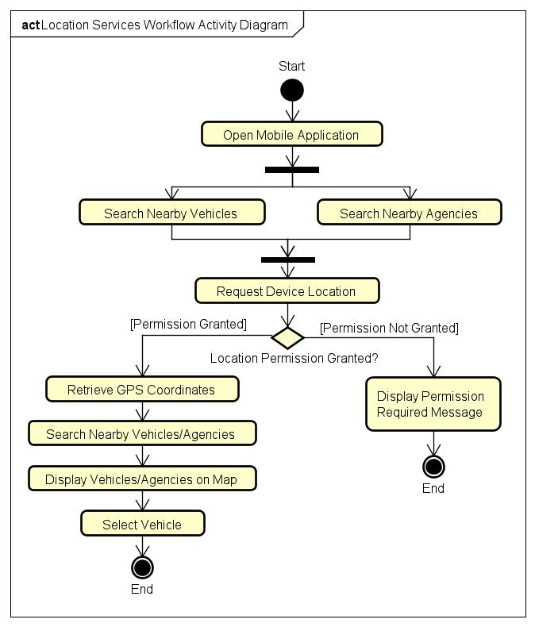
Decision Point
Figure 15 - Location Services Workflow Activity Diagram
Location Permission Granted?
- Yes: Retrieve the customer's location and display nearby vehicles.
- No: Display a message requesting location permission.
Conclusion
The Location Services Workflow Activity Diagram shows the integration of mobile GPS technology with the KriGo platform and its use in finding the nearby vehicles.

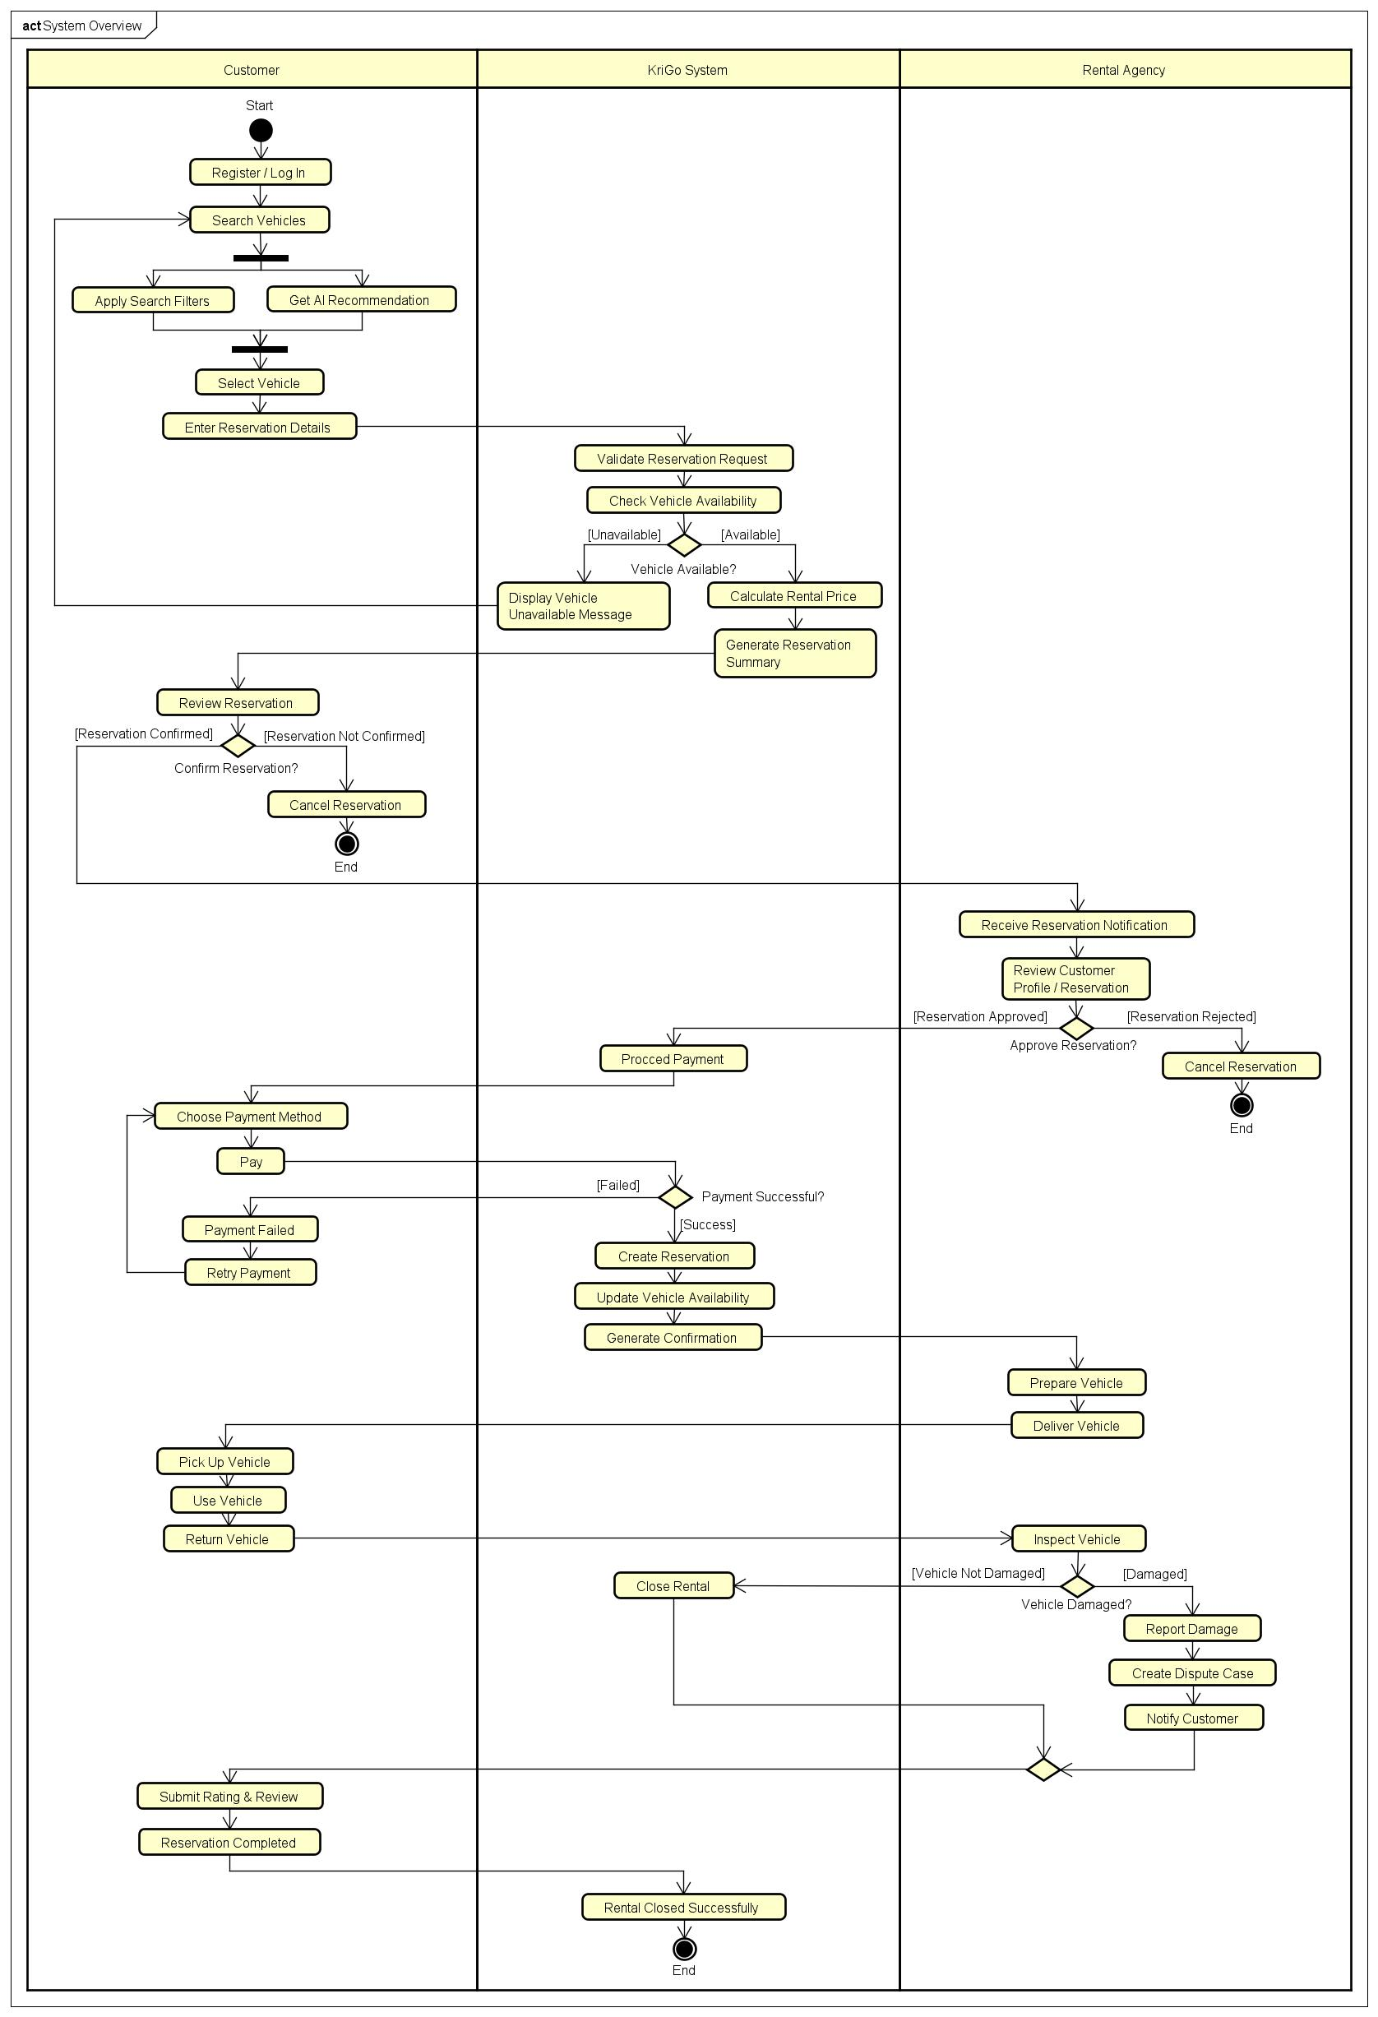
System Overview Activity Diagram (Customer Jurney)
Figure 16 - System Overview Activity Diagram

